Write here, centralized, the title of the work, in type Times New Roman,
size 12, boldface.

Name and Surname 1st Author⁽¹⁾, Name and Surname 2nd Author⁽²⁾, Name and Surname 3rd Author⁽³⁾

(1) Institutional Affiliation, City, Country, e-mail
(2) Institutional Affiliation, City, Country, e-mail
(3) Institutional Affiliation, City, Country, e-mail

Abstract
To facilitate the preparation of the book, the authors are asked to use this model, with letter types and sizes specified in each section.
The text must be sent in a .docx or .tex file, together with a .pdf version, specially for the editors to check the placement/size of formulas, graphics, etc. All the data of the authors must be included. Once received, the editorial committee will put the papers in blind form in order for them to be properly evaluated.
As for the filename, one shall use the first surname and name (in this order) of the first author, without spaces: SurnameName.docx, eg. “PerezJuan.docx. The subject of the message will be “Logic Book ST”.
The text must be written using letter type “Times New Roman”. The title will be written in boldface and centered, size 12, and shall not have more than 15 words.
Bellow the title, leaving a blank line, size 12, must be written the names and surnames of the auhors (size 9, normal typeface), centralized, with references (via as many superscripts as needed) to their respective institutional affiliations, indicating the city and country, as well as their e-mail. The name and surname of the first author must match the one used in the filename .docx or .tex to be sent.
The bold-face word “Abstract” will be placed two 11-sized lines bellow the authors’ affiliations. The abstract must convey to the reader a clear synthesis of the proposal and content of the paper. It shall not exceed 300 words and must be written in normal face letters, size 11, justified text and with 1cm of indentation at the beginning of each paragraph. The abstract should not contain bibliographic references, footnotes, graphics or tables.
The final text must be sent to the e-mail rodrigo.lopez@usal.es or diegofernandess@usal.es.
Keywords: There must be at least three and at most five keywords not appearing in the title, font size 11.

1. Introduction, presentation or 1st section, size 11, bold-face
After leaving a blank line, size 11, the first and following numbered sections, also will be written bold-face, size 11. Each new paragraph must have indentation of 1cm.
The maximum allowed extension for the final texts is of 10000 words, including all the items of the text, to wit: title, abstract, keywords, tables, captions, footnotes, references, etc.

2. The following sections, analogously, bold-face, size 11
The footnotes must be in the body of the text and be as few as possible. They must be numbered and not contain neither citations nor bibliographic references.
The references in the text must indicate in parenthesis: Surname of the author, year of publication and page number. The complete guide for citations and references to be followed can be found in the website: http://www.selecciondetextos.cl/instrucciones-para-autores/
If the authors want to quote textually a phrase of at most three lines, it shall be placed between commas in the body of the text. From four lines on, the quotation must be placed apart, after a colon:
The quotations must be reproduced indented 1cm to the right, without commas and with indentation of 1cm in the first word at each paragraph.

3. Bibliographic References
Only cited works shall be contained in the references, and they will be ordered alphabetically by author. AS it was said above, the style of citations and references must follow the directions in the referred website.
The images, e.g. illustrations, photographs, tables, drawings, graphics must be sent in separated files, in each of the usual formats: Jpeg, Tiff, etc. The files must be in high resolution in order to be properly reproduced. In the case of third party images, the authors must have the corresponding permission for reproduction. In the body of text, they must be presented sequentially numbered, referred to in square brackets e.g. [Figure 1], and inserted in the place where the authors consider most convenient, in the appropriate size they shall appear in the book and with its caption:

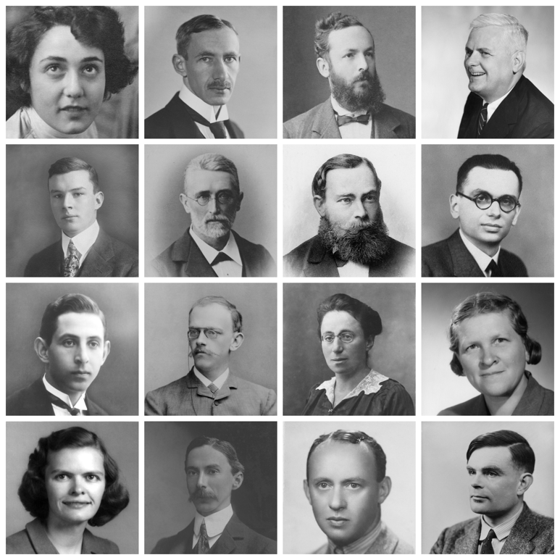
Figure 1. Size 9, place a brief description of the figure (indicating between parenthesis its origin)

The works not following the above format will be returned to their authors.
In case some corrections are proposed by the editors, the authors will be responsible for them.

